Bio Time 4-5 SDK Ocx Resigration

- Open Command Prompt(CMD) as administrator

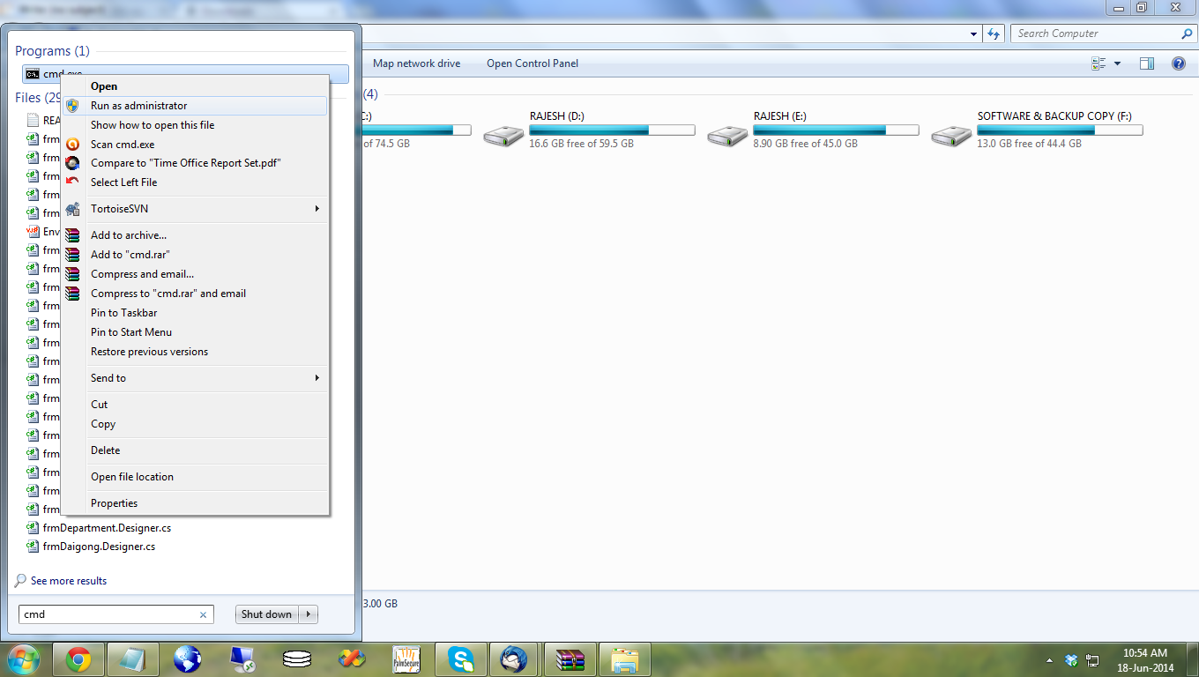

- OCX Registration Process:

→ C:\Windows\system32\regsvr32 “Full Path of Sbxpc.ocx”.

